Day 9 - Java Data Structures Part I Notes

Have someone install Spring Boot

Homework review

Create directory C:\TTS\Day 9 - Java Data Structures Part I

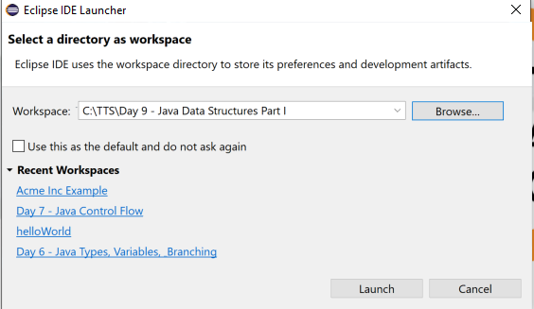

Create new java proect data structures 1

Create package com.tts

Create Class Main

Create Class Controller

// Have students instantiate class

Controller controller = **new** Controller();

// Have students add helloWorld method and run it

**public** **void** helloWorld() {

System.***out***.println("Hello World");

}

(show slides to class 1-7)

// add arraysDemo method to Controller

**public** **void** arraysDemo() {

String[] names = {"John", "Daryl", "Mike", "Sarah", "Michelle"};

System.***out***.println(names[1]);

}

(Slide 8 & following)

// add arrayListDemo method to Controller

// Copy code on slide 9 to arrayListDemo and discuss

// add System.***out***.println(names); after each change

// Add code from slide 10 and run

(Copy slide 11 to arrayConversion())

// run debugger on line List<String> arrayString = Arrays.*asList*(str); examine results in variables, show different perspectives

// put break after String myString and change value to “I really hate icecream!”

// Convert ArrayList back to String (Slide 12)

Object[] arrayString = listString.toArray();

String myStringAgain = Arrays.*toString*(arrayString);

System.***out***.println(myStringAgain);

System.***out***.println(myStringAgain.replace("[","").replace("]","").replace(",", " "));

(Slide 13 Hashmaps)

// Create new hashMapDemo() method

(Slide 14 copy slide)

HashMap<String, Integer> person = **new** HashMap<>(); // is not right

Map<String, Integer> person = **new** HashMap<String, Integer>(); // is better

// Run it and discuss

(Slide 15 add in additional commands)

// duplicates not allowed

HashSet vs **HashMap**

HashSet does not allow **duplicate** elements that means you can not store **duplicate** values in HashSet. **HashMap** does not allow **duplicate** keys however it allows to have **duplicate** values. HashSet permits to have a single null value. **HashMap** permits single null key and any number of null values.

Loops (Slide 16)

In Class Challenge, slide 18 For Loops

In Class Challenge, slide 20 While Loops

In Class Challenge, slide 22 Do While Loops

(Slide 25 copy code for looping arrayList)

In Class Challenge slide 26 ArrayList Loop

In class Challenge slice 28 HashMap loop // will be case sensitive

Will need scanner code

Scanner scanner = **new** Scanner(System.***in***);

System.***out***.println("Type an animal and I'll echo it back");

String animal = scanner.nextLine();

System.***out***.println(animal);

Slide 29 homework (maybe do in class if time left)

Try to load Spring Boot for everyone

Work on Acme Inc development